

Duet Module Interface Specification

for the

Dynalite DyNet 1
Lighting System

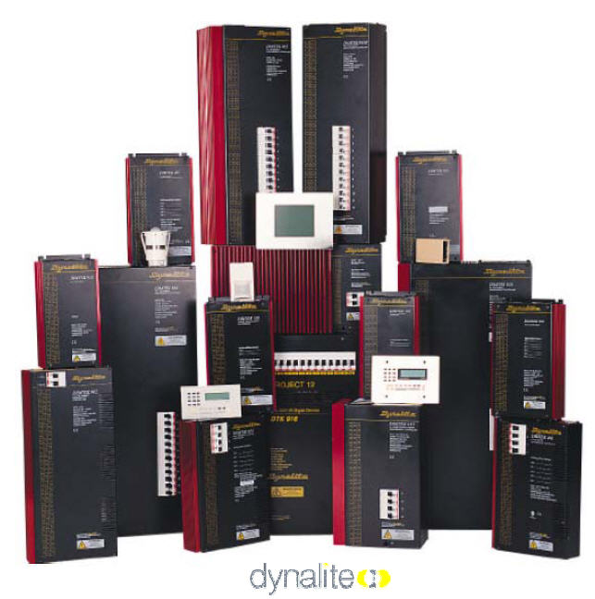

TABLE OF CONTENTS

Introduction 3
Serial Control 3
IP Control 4
Overview 5
Implementation 6
Port Mapping 7
Channels 7
Command Control 8
Command Feedback 12
Device Notes 14
Programming Notes 14
Adding Functions to Modules 15
Commands to the device 15
Responses from the device 15

Revision History

Date | Initials | Revision | Comments
05-05-2010 | SGN | 1.0.0 | Initial release.

Introduction

This is a reference manual to describe the interface provided between an AMX NetLinx system and a Dynalite DyNet dimmer. The Dynalite DyNet dimmer supports an RS-232 serial protocol via the DTK622-232 PC-Node or IP via the DNG100BT Network Interface.

This module was written using Café Duet firmware version 3.50.430. NetLinx Studio version 3.0 build 3.0.1.350, Café Duet application platform and runtime version 1.15.230 and Café Duet application version 1.8.85.

Serial Control
Serial control occurs via the Dynalite DTK622-232 PC-Node. The required communication settings are a baud rate of 9600, 8 data bits, 1 stop bit, no parity, and handshaking off. The cable for this device is FG#10-752. The wiring diagram for this cable is as follows:

AMX NI DB-9 Male
5 (GND) 5 (GND)
2 (RXD) 2 (TXD)
3 (TXD) 3 (RXD)

Important Note: Use only a three conductor cable to connect to the NetLinx master. Using a larger number of conductors, or a third-party cable, may result in communication errors and module problems.

Important: There is a jumper inside the DTK622-232 serial interface located near the RS232 connector. It must be set at the position furthest AWAY from the RS232 connector for the AMX module to work.

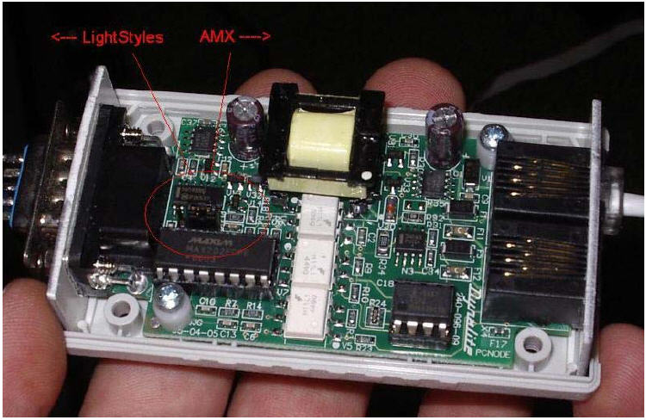

IP Control
IP control occurs via the Dynalite DNG100BT interface module. The Dynalite installer will provide the IP address and port of communication between the AMX NetLinx master and DyNet. The setup in DLight software is shown below.

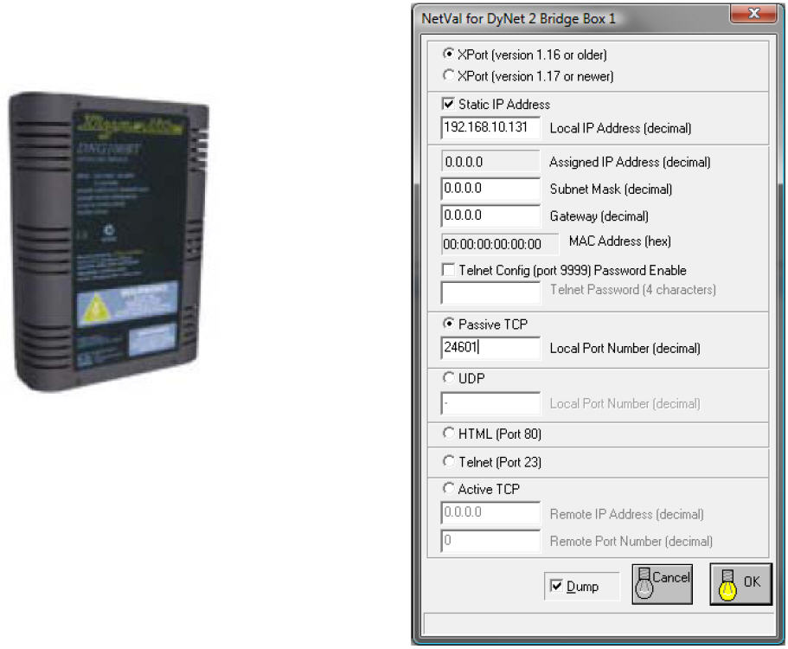

The DNG100BT can also be setup using Hyperterminal on any PC. The typical factory default IP address is 192.168.10.10 and default IP port is 24601. Here is an example of the setup:

Dynalite DNG100BT Configuration Port Slave v3.7.1.0
MAC address 00204AA3B166
Software version V3.7.1.0 (081216) CPK6101_XPTEX
Press Enter for Setup Mode
*** basic parameters
Hardware: Ethernet TPI
IP addr 192.168.10.10, gateway 000.000.000.000, netmask 255.255.255.0
************* Gateway Settings **************
Box Number : 71
Enabled Gateway Type(s) : Passive TCP
UDP Port : 0
Local Port (used in Passive TCP) : 24601
Remote Port (used in Active TCP) : 0
Remote IP (used in Active TCP) : 000.000.000.000

Important: The DNG100BT master firmware must be V1.25 or later.
Its TCP/IP slave firmware version must be V3.7.1.0 or later.
The Duet module must be informed of the IP address and port of the device it is to connect to. This must be done manually via a telnet session, or can be automated from the UI module. The IP address and port must be set using the ‘PROPERTY-‘ command. The ‘REINIT’ command is used to notify the Comm. module that new properties are now available and to start using them. When these two commands are used in the appropriate order, the Comm. module will attempt to connect to the specified IP address and port periodically until a connection is made or a new IP address and port is submitted using the ‘PROPERTY-‘ and ‘REINIT’ commands. Please see the Programming Notes section for additional information.

Overview

The COMM module translates between the standard interface described below and the lighting system serial protocol. It parses the buffer for responses from the lighting system, sends strings to control the lighting system, and receives commands from the UI module or telnet sessions.

A User Interface (UI) module is also provided. This module uses the standard interface described below and parses the command responses for feedback.

The following diagram gives a graphical view of the interface between the interface code and the Duet module.
Dynalite Dynet Lighting System
Duet
COMM Module
NetLinx
UI Module
Virtual
Device
SNAPI

Some functionality in the device interface may not be implemented in the API interface. In cases where device functions are desired but not API-supported, the PASSTHRU command may be used to send any and all device-protocol commands to the device. See the PASSTHRU command and the Adding Functions to Modules section for more information.

A sample UI module and a touch panel file are provided in the module package. These are not intended to cover every possible application, but can be expanded as needed by a dealer to meet the requirements of a particular installation.

Implementation
To interface to the AMX Dynalite DyNet dimmer module, the programmer must perform the following steps:
- Define the device ID for the lighting system that will be controlled.
- Define the virtual device ID that the Dynalite DyNet dimmer COMM module will use to communicate with the main program and User Interface. Duet virtual devices use device numbers 41000 - 42000.
- If a touch panel interface is desired, a touch panel file Dynalite Dynet Light System.TP4 and module (Dynalite Dynet Light System.apw) have been created for testing.
- The Duet Dynalite DyNet dimmer module must be included in the program with a DEFINE_MODULE command. This command starts execution of the module and passes in the following key information: the device ID of the lighting system to be controlled, and the virtual device ID for communicating to the main program.

An example of how to do this is shown below.
DEFINE_DEVICE
dvDynaliteDyNetLightSystem = 5001:2:1 // Physical serial port.
vdvDynaliteDyNetLightSystem = 41001:1:0 // Virtual device.
dvDynaliteDyNetLightSystemTp = 10001:1:0 // Touch panel

DEFINE_CONSTANT
VOLATILE CHAR sLightAddress[20][20] =
{
'255:1:1', //Example light addresses
'255:1:2', //Change the addresses to match your system.
'255:1:3',
'255:1:4',
'',
…
''
}

DEFINE_VARIABLE
DEV vdvDev[] = {vdvDynaliteDyNetLightSystem}
INTEGER nDynaliteDyNetLightSystem = 1
INTEGER nDynaliteDyNetLightSystemPages[] = { 1 }
INTEGER nModulePages[] = { 3 }

DEFINE_START
DEFINE_MODULE 'Dynalite DyNet LightSystemComponent' lightSystem(vdvDev, dvDynaliteDyNetLightSystemTp, nDynaliteDyNetLightSystem, nDynaliteDyNetLightSystemPages, sLightAddress)
DEFINE_MODULE 'Dynalite DyNet ModuleComponent' module(vdvDev, dvDynaliteDyNetLightSystemTp, nDynaliteDyNetLightSystem, nModulePages)

// Define your communications module here like so:
DEFINE_MODULE 'Dynalite_DyNet_Comm_dr1_0_0' comm(vdvDynaliteDyNetLightSystem, dvDynaliteDyNetLightSystem)

Upon initialization the AMX Comm module will communicate with the lighting system and information will be exchanged.

Port Mapping

Virtual Device | Channels | Levels | Control | Feedback
41001:1:0 | All Channels | All Levels | All Commands | All Feedback
Table 1 - Port Mapping

Channels

The UI module controls the Dynet lighting system via channel events (NetLinx commands pulse, on, and off) sent to the COMM module. The channels supported by the COMM module are listed below. These channels are associated with the virtual device(s) and are independent of the channels associated with the touch panel device.

Channel | Description
251 | ON: Device is Online – used for feedback only  OFF: Device is not Online
252 | ON: Data is Initialized – use for feedback only  OFF: Data is not Initialized
Table 2 - Virtual Device Channel Events

Command Control

The UI module controls the Dynalite Dynet lighting system via command events (NetLinx command send_command) sent to the COMM module. The commands supported by the COMM module are listed below.

Command | Description
?DEBUG | Query the current debug state of the module.  ?DEBUG
DEBUG-<value> | Set the state of debugging messages in the UI module and the Comm. module.  Note: See Programming Notes section.  <value> : 1 = set only error messages on  2 = set error and warning messages on  3 = set error, warning & info messages on  4 = set all messages on  DEBUG-1
?LIGHTSYSTEMLEVEL-  <address> | Query the level of the specified light. This command is relevant for light loads only. Note that global addresses are not supported for this query. I.e. “ALL” cannot be used to query multiple light levels.  <address> : <join:area:channel>  join = 0..255  area = 1..255  channel = 1..255  ?LIGHTSYSTEMLEVEL-255:1:1
LIGHTSYSTEMLEVEL-<address>,  <level> | Set the level of the specified light. This command is relevant for light loads only.  Note: Use “ALL” with care!  <address> : <join:area:channel>  join = 0..255  area = 1..255 or ALL  channel = 1..255 or ALL  <level> : 0..255  LIGHTSYSTEMLEVEL-255:1:1,255  LIGHTSYSTEMLEVEL-255:1:ALL,0  LIGHTSYSTEMLEVEL-255:ALL:ALL,0
LIGHTSYSTEMLEVEL-<address>,  <level>,  <interval> | Set the level of the specified light in the specified number of seconds. This command is relevant for light loads only.  Note: Use “ALL” with care!  <address> : <join:area:channel>  join = 0..255  area = 1..255 or ALL  channel = 1..255 or ALL  <level> : 0..255  <interval>: 1..1260 (time, in seconds, to take to  reach the level)  LIGHTSYSTEMLEVEL-255:1:1,255,100 (100s to level 255)  LIGHTSYSTEMLEVEL-255:1:ALL,0,2 (2s to level 0)  LIGHTSYSTEMLEVEL-255:ALL:ALL,0,1260 (21 minutes to level 0)
LIGHTSYSTEMRAMP-<address>,  <state> | Set the ramping state of the light level associated with the specified light. This command is relevant for light loads only.  <address> : <join:area:channel>  join = 0..255  area = 1..255  channel = 1..255  <state> : DOWN  UP  STOP  LIGHTSYSTEMRAMP-255:1:1,UP
?LIGHTSYSTEMSTATE-  <address> | Query the state of the specified light. Note that global addresses are not supported for this query. I.e. “ALL” cannot be used to query multiple light levels.  <address> : <join:area:channel>  join = 0..255  area = 1..255  channel = 1..255  ?LIGHTSYSTEMSTATE-255:1:1
LIGHTSYSTEMSTATE-<address>,  <state> | Set the state of the specified light. This command is relevant for light loads and presets.  <address> : <join:area:channel>  join = 0..255  area = 1..255 or ALL  channel = 1..255 or ALL  channel can also contain the following  commands:  PRE = preset  PAN = panic mode  KEY = keypad lockout  <state> : TOGGLE  ON  OFF  LIGHTSYSTEMSTATE-255:1:1,ON (area 1, channel 1 is turned on)  LIGHTSYSTEMSTATE-255:1:1,TOGGLE (toggle area 1, channel 1)  LIGHTSYSTEMSTATE-15:1:1,OFF (area 1, channel 1 is turned off if the lighting controller join address works with bitmask of 15)  LIGHTSYSTEMSTATE-255:1:PRE2,ON (area 1, preset 1 is turned on)  LIGHTSYSTEMSTATE-255:1:PRE45,OFF (area 1, preset 45 is turned off)  LIGHTSYSTEMSTATE-255:2:PAN,ON (turns on panic mode in area 2)  LIGHTSYSTEMSTATE-255:2:PAN,OFF (turns off panic mode in area 2)  LIGHTSYSTEMSTATE-255:1:KEY,ON (enables all keypads in area 1)  LIGHTSYSTEMSTATE-255:1:KEY,OFF (disables all keypads in area 1)
PASSBACK-<state> | Enable or disable response reporting from the device. When enabled device responses will be sent as strings to the virtual device.  Note: By default, this is set to off at startup.  <state> : 0 = Off (default)  1 = On  PASSBACK-0
PASSTHRU-<string> | Allows user the capability of sending commands directly to whatever unit is attached with minimal processing by the Duet module. User must be aware of the protocol implemented by the unit to use this command. This gives the user access to features that may not be directly supported by the module. For more information, see the “Adding Functions to Modules” section below.  Note: The checksum is automatically calculated and appended to the command.  <string> : string to send to unit  "'PASSTHRU-',$1C,$01,$00,$63,$00,$00,$FF" (request current  preset of area 1)
?PROPERTY-<key> | Get the value of a property <key>. If the value is not initialized, an empty string is returned.  <key> : IP_Address  Port  ?PROPERTY-IP_Address
PROPERTY-  <key>,  <value> | Set the value of property <key> to <value>. This must be followed by the REINIT command to take effect. These values are not initialized by default.  <key> : IP_Address  <value> : string representing an IP address  <key> : Port  <value> : n..65535  PROPERTY-IP_Address,10.0.0.5  PROPERTY-PORT,1025
REINIT | Re-initializes the communication link and data.  Note: This command deletes any messages waiting to go out to the device.  REINIT
?VERSION | Query for the current version number of the Duet module.  ?VERSION
Table 3 – Send Command Definitions

Command Feedback

The COMM module provides feedback to the User Interface module for Dynalite Dynet lighting system changes via command events. The commands supported are listed below.

PLEASE NOTE: Feedback is only provided when there is a state change. If no state change resulted from the command sent in, then no feedback will be returned.
Command | Description
DEBUG-<value> | Returns the state of debugging messages in the UI module and the Comm. module.  <value> : 1 = set only error messages on  2 = set error and warning messages on  3 = set error, warning and info messages on  4 = set all messages on  DEBUG-1
LIGHTSYSTEMLEVEL-<address>,  <level> | Reports the current light level of the specified light.  <address> : <join:area:channel>  join = 0..255  area = 1..255  channel = 1..255  <level> : 0..255  LIGHTSYSTEMLEVEL-255:1:1,255
LIGHTSYSTEMRAMP-<address>,  <control> | Reports the current ramping state of the specified light.  <address> : <join:area:channel>  join = 0..255  area = 1..255  channel = 1..255  <control> : DOWN  UP  STOP  LIGHTSYSTEMRAMP-255:1:1,UP
LIGHTSYSTEMSTATE-<address>,  <state> | Reports the current state of the specified light.  <address> : <join:area:channel>  join = 0..255  area = 1..255  <state> : ON  OFF  LIGHTSYSTEMSTATE-255:1:1,ON
PROPERTY-<key>,<value> | Feedback on the value of property <key>.  Note: An empty string is returned if the property has no value.  <key> : IP_Address  <value> : string representing an IP address  <key> : Port  <value> : 1..65535  PROPERTY-IP_Address,10.0.0.2  PROPERTY-Port,24601
VERSION-<version> | Reports the version number of the module.  <version> : xx.yy.zz = module version number  VERSION-1.0.0
Table 4 - Command Feedback Definitions

Device Notes
- Since it is possible to recall the same preset in all 255 areas using “ALL” area addressing, it should be used with utmost discretion. It is recommended to direct commands to specific areas, especially Base Link areas that have been linked to other areas by the lighting installer. This is particularly important if motorized systems are connected to channels.
- The join portion of the address can be used to filter messages to certain devices on the network. Normally, a join of 255 is used so all devices get the message.
- The device does not provide asynchronous feedback, so it is possible for the module feedback to get out of sync with the device. This is especially true when using global commands or presets. When a single channel is set, the module will immediately query that channel for proper feedback. When a preset or global address is used, the module does not know which channels are involved, so the channels cannot be queried.

Programming Notes
- Since the protocol does not provide a consistent query command, the module does not use a heartbeat command. Therefore, the module is always online and initialized.
- Due to unique addressing, the module is unable to query for the initial light levels and states. It is suggested to add ?LIGHTSYSTEMLEVEL queries to the online event.
- The LIGHTSYSTEMLEVEL command loses resolution when the interval is greater than 255 seconds. Once the interval goes higher than 255 seconds, the seconds are converted into minutes. E.g. sending an interval of 300 seconds and 320 seconds will both result in an actual interval of 5 minutes.

PLEASE NOTE: In order to establish a communication connection between the module and the device, the module must know what IP address and port to connect to. Use the PROPERTY- command to set the module’s IP address and port and then use the REINIT command to force it to take affect. Here is an example of how these two commands are used:
Send_Command 41001:1:0, ‘PROPERTY-IP_Address,192.168.103.30’
Send_Command 41001:1:0, ‘PROPERTY-Port,1025’
Send_Command 41001:1:0, ‘REINIT’
Note that your virtual device (41001:1:0), the IP address of your device (192.168.103.30) and port (1025) may differ from this example. Substitute the appropriate values where necessary.

Adding Functions to Modules

Commands to the device
This module supplies a mechanism to allow additional device features to be added to software using the module. This is the ‘PASSTHRU-‘ command, which allows protocol strings to be passed through the module. The device-specific protocol must be known in order to use this feature.

As an example, suppose the module has not implemented the “query current preset” feature. The required command is 1CH, 01H, 00H, 63H, 00H, 00H, FFH, followed by a checksum. The documentation for the ‘PASSTHRU-‘ command specifies that the module will automatically generate the checksum. In this case, the following string should be sent from the UI code to implement “query current preset.”

send_command vdvDevice, "'PASSTHRU-',$1C,$01,$00,$63,$00,$00,$FF"

(This command queries for the current preset in area 1, with a join of 255).

The reason to use ‘PASSTHRU-‘ instead of sending a protocol string directly to the device port is that the device may require command queuing, calculation of checksums, or other internal processing, which would not be done if the string was sent directly. Because of this, it is best to filter all communication TO the device through the module. (The module documentation will indicate any processing that will be automatically done to the ‘PASSTHRU-‘ command like checksum calculation.)

Responses from the device
The module will automatically interpret replies from the device and pass these on to the application code according to the documented API. Some device replies may not be passed on to the application code.
To see all replies from the device unfiltered by the module, enable PASSBACK and use a DATA_EVENT with a string handler in the UI code. Again, the device-specific protocol must be known in order to interpret these responses. Even when PASSBACK is enabled, the module will still interpret device responses according to the standard API.

